



**GROUP 05 – LIST OF MEMBERS**

| **No.** | **ID** | **Name** | **Work Evaluate** |
| --- | --- | --- | --- |
| 1 | K204160669 | Vu Van Son | 100% |
| 2 | K204162000 | Chau Nguyen Huong Thao | 100% |
| 3 | K204162006 | Huynh Hong Uyen | 100% |
| 4 | K204162009 | Nguyen Tuong Vy | 100% |

**TABLE OF CONTENTS**

**CHAPTER I: OVERVIEW** **4**

**I.1. Project description** **4**

**I.2. Project target** **4**

**CHAPTER II: OVERALL ANALYSIS** **5**

**II.1. Overall main function** **5**

II.1.1. Login and register 5

II.1.2. Weather forecast 5

II.1.3. Travel Planner 5

II.1.4. Healthcare 6

**II.2. Use case** **6**

**II.3. System Data Flow Diagram (DFD)** **6**

**CHAPTER III: DETAILED ANALYSIS BUSINESS PROCESS** **7**

**III.1. Function “Login”** **7**

III.1.1. Business process modeling notation (BPMN) 7

III.1.2. Data flow diagram (DFD) 9

III.1.3. Sequence Diagram 11

III.1.4. Mockup 12

III.1.5. Validation 14

**III.2. Function “Weather forecast”** **16**

III.2.1. Business process modeling notation (BPMN) 16

III.2.2. Data flow diagram (DFD) 18

III.2.3. Sequence Diagram 20

III.2.4. Mockup show detailed weather forecast 21

III.2.5. Validation 22

**III.3. Function “Travel Planning”** **23**

III.3.1. Data flow diagram (DFD) 23

III.3.3. Business process modeling notation (BPMN) 24

III.3.4. Sequence diagram 27

III.3.5. Mockup 29

III.3.6. Validation 29

**III.4. Function “Healthcare”** **30**

III.4.1. Data flow diagram (DFD) 30

III.4.2. Business process modeling notation (BPMN) 34

III.4.3. Sequence Diagram 45

III.4.4. Mockup 46

III.4.5. Validation 47

**III.5. Function “Personal Settings”** **51**

III.5.1. Business process modeling notation (BPMN) 51

III.5.4. Mockup 52

# CHAPTER I: OVERVIEW

## **I.1. Project description**

Weather is one of the factors that greatly affect the quality of outings, work, ... Weather is also one of the factors that cause unannounced "allergic" diseases. Therefore, forecasting the weather at the destination before going there is always an important part of any trip planning. From there, we can avoid bad weather days, and we can prepare the necessary items for the trip.

For the reasons mentioned above, the application designed by the team will solve those things. From weather forecasting, health monitoring to trip scheduling (including transportation, hotels, attractions, ..), it makes the app an absolute must. Versatile and amazing application. Monitoring the health status can assist users when they are in trouble. Having a pre-scheduled schedule saves a lot of time for users, in addition, for those who are new to that place for the first time, it is very useful to have a pre-scheduled schedule because the schedule will already have the places to go and Users will not need to learn too much in advance. Scheduling also helps to optimize costs including from time to money.

## **I.2. Project target**

The app was built with three main goals in mind:

* Weather forecast
* Plan your trip
* Monitor health status

# CHAPTER II: OVERALL ANALYSIS

## **II.1. Overall main function**

### II.1.1. Login and register

To be able to use the app, users must have a valid account to authenticate them. Which protects their private content and gives them personalized experience. So the app requires users to register or login the system to experience the functions.

### II.1.2. Weather forecast

When users turn on Cellular data/Wifi and select the location, WETH will help users to know the current and near future weather forecasting information by automatically connecting to the FORECA data center to get data information at the location that users used to input. Users can receive information of location, time, last update time, temperature, humidity, detailed information, disaster forecast, and other necessary information.

The application automatically updates weather information every 1 minute if users turn on Cellular data/Wifi, and will send recommendations to users if a natural disaster occurs at that location. In case the Cellular data/Wifi is not connected, the system displays the weather information at the last location entered by users before.

In addition, users can still view weather forecast information without logging into the application.

### II.1.3. Travel Planner

An advanced feature of the application is Travel Planner that allows users to explore their travel journey and will be presented in the “Travel” tab. According to the requirements provided by users, our system will recommend a list of appropriate itineraries. The displayed results will be considered based on:

* Knowledge base stores user’s health records, interests …
* Weather forecast for the intended traveling time and alerts whether have any natural catastrophe. By the way, we also give users advice about what type of taken clothes, necessary medicines, etc.

Since users selected their wanted itineraries, the system will update automatically to the traveling schedule, which helps to present all events of an itinerary and alert them about upcoming events or any changes during their journey.

### II.1.4. Healthcare

The app requires the user to connect to the smartwatch, connect to the medical record and allow access to the phone book. Smart Watch will perform the function of providing information such as heart rate, blood pressure, body temperature, weight, ... Medical Record will provide a history of diseases that the user has ever had and finally is a Phone book that will be used to call loved ones in an emergency situation.

## **II.2. Use case**

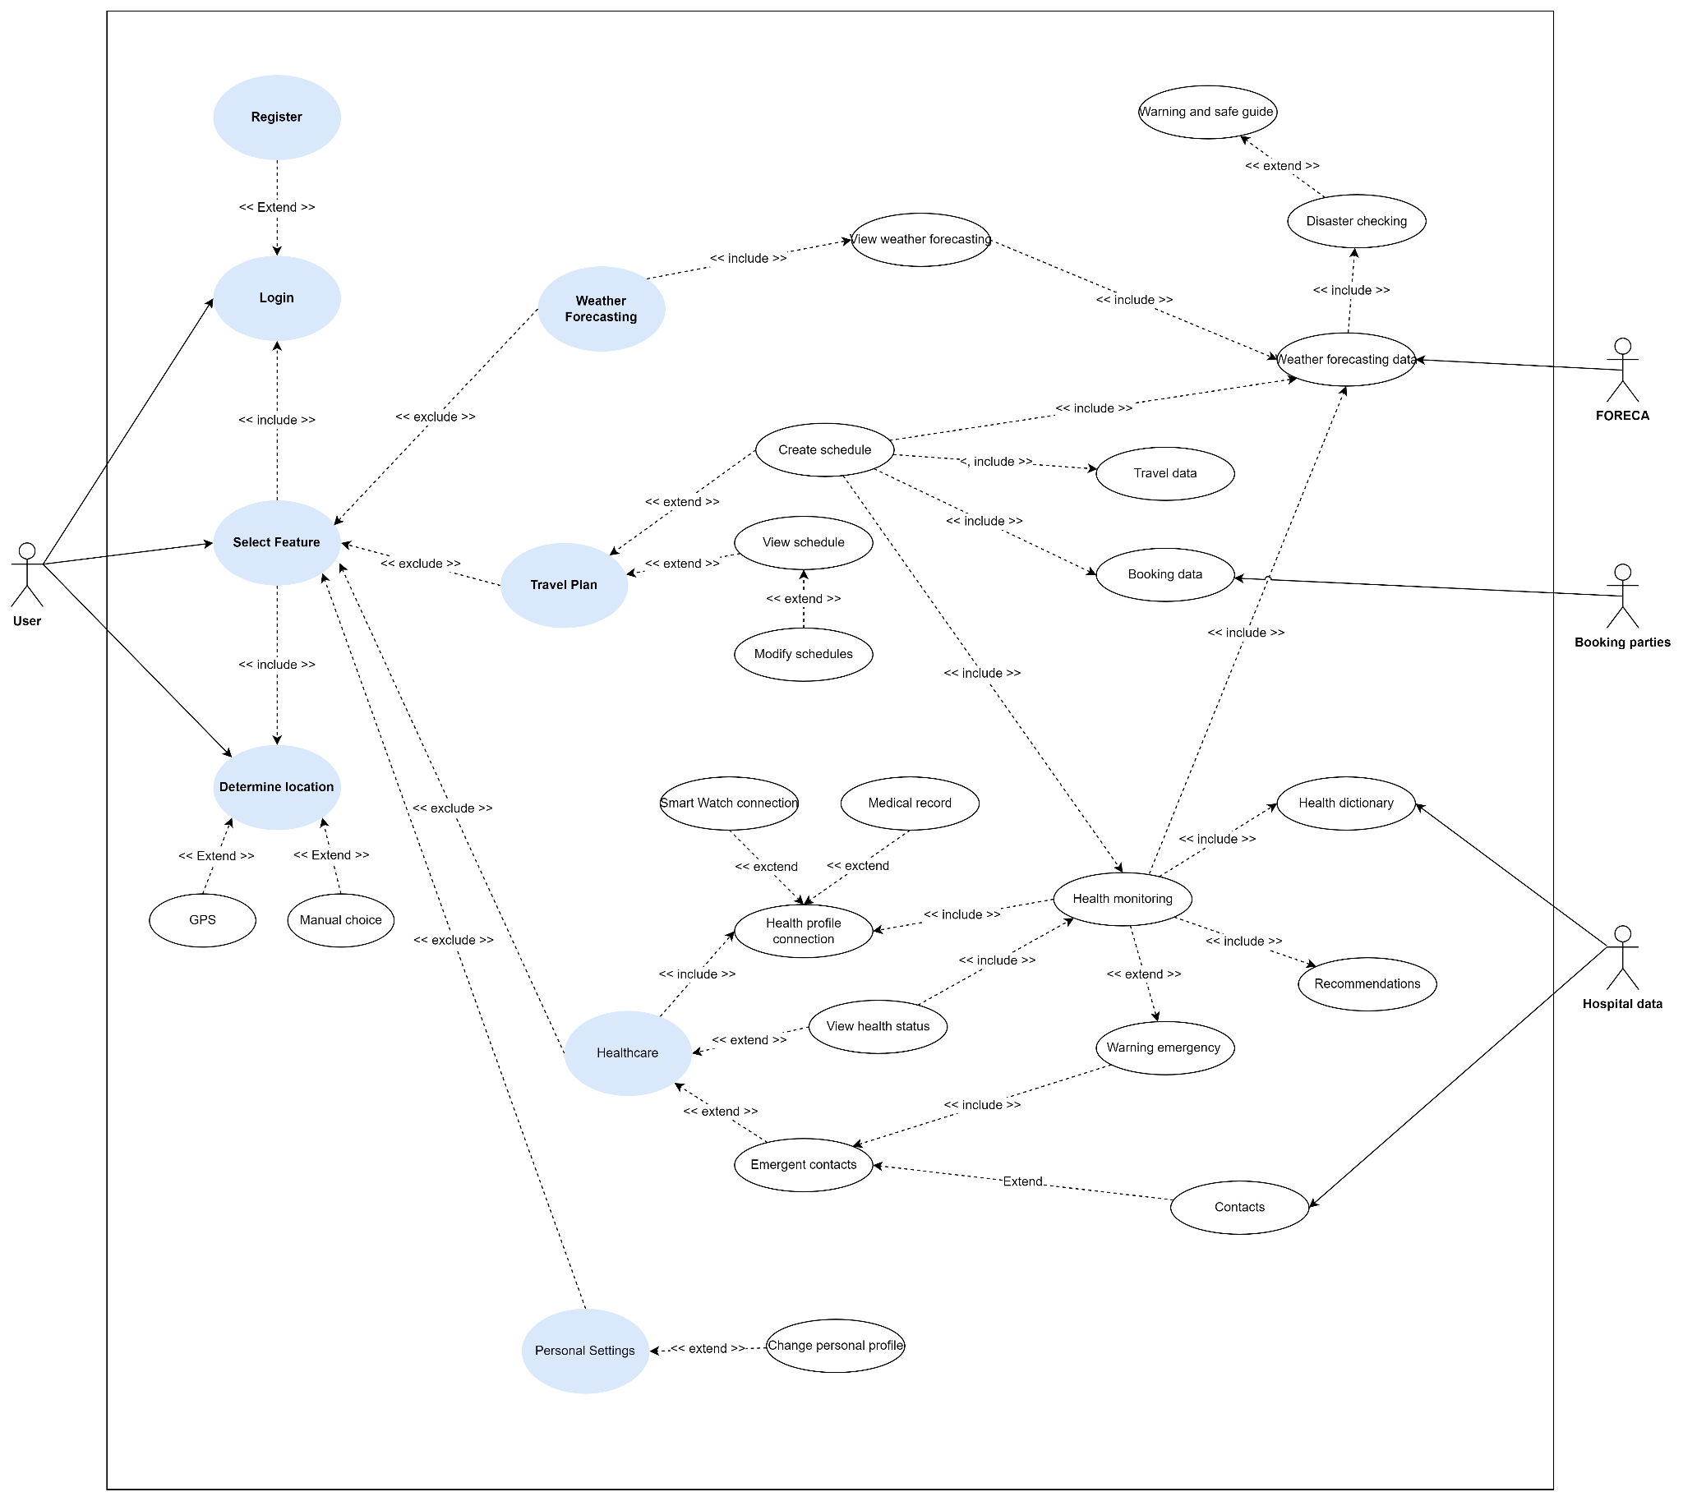

*Figure. System use case.*

## 

## II.3. System Data Flow Diagram (DFD)

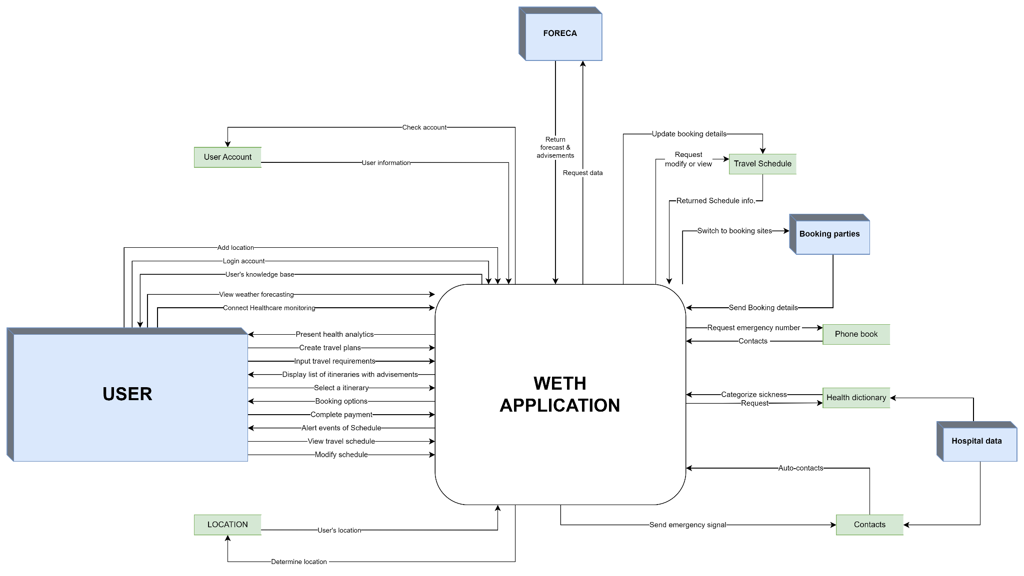

*Figure. System data flow diagram.*

# CHAPTER III: DETAILED ANALYSIS BUSINESS PROCESS

## **III.1. Function “Login”**

### III.1.1. Business process modeling notation (BPMN)

User must Sign in/Sign up their account if user wants to use the app for the first time since it was downloaded. This requires the system must check if the app has any account?

* Case 1: If user have not yet been signed in: Show up login screen
  + Case 1.1: If user already has an account and has fully information to fill out :
    - Check if all input information is correct? If not, the system will return the login screen for user to retype their account information again. If all are correct, go to the main screen.
    - If users already have an account but forget their password. They can choose the forget password function.
  + Case 1.2: If user don’t have any account, they can choose 2 way for register functions :
    - Enter information into the fields. If the data has any error, please type the information to the field again. There are 2 options for user name, which is user’s mail or user’s phone number. And the system will send a message with code text for activation of their account.
* Both cases 1.1 & 1.2: If users login with Facebook or Google, the system will send a request for the device to load the respective information of user’s account.
* Case 2: If user logged in, the system gets all the user data and directly show to the weather forecast screen.

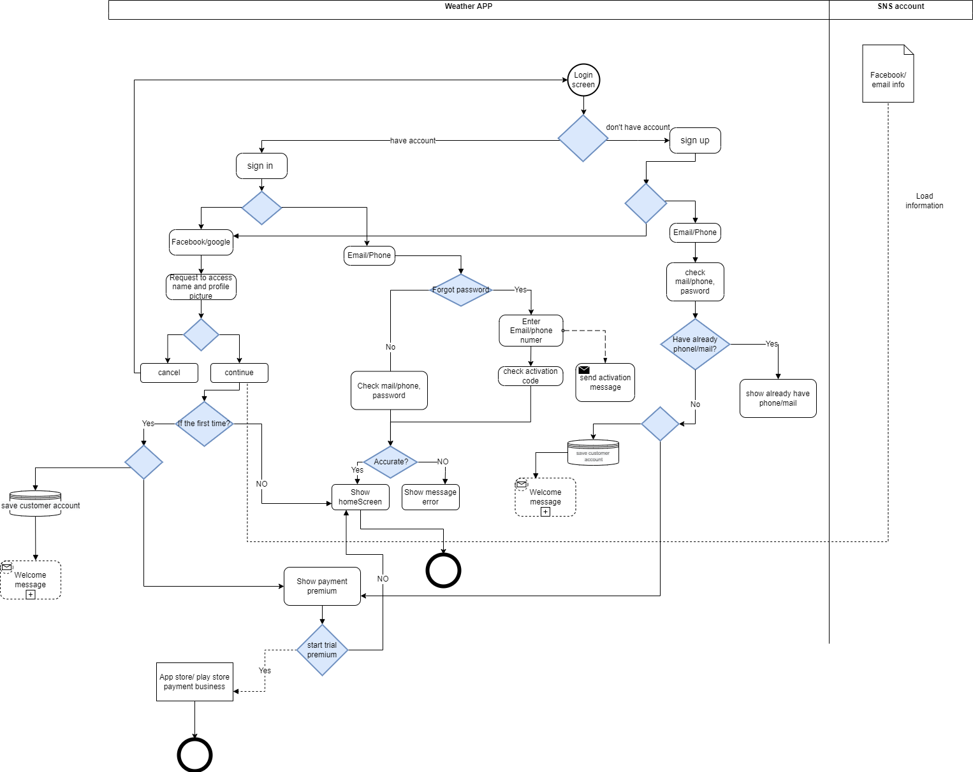

*Figure : Login BPMN*

### III.1.2. Data flow diagram (DFD)

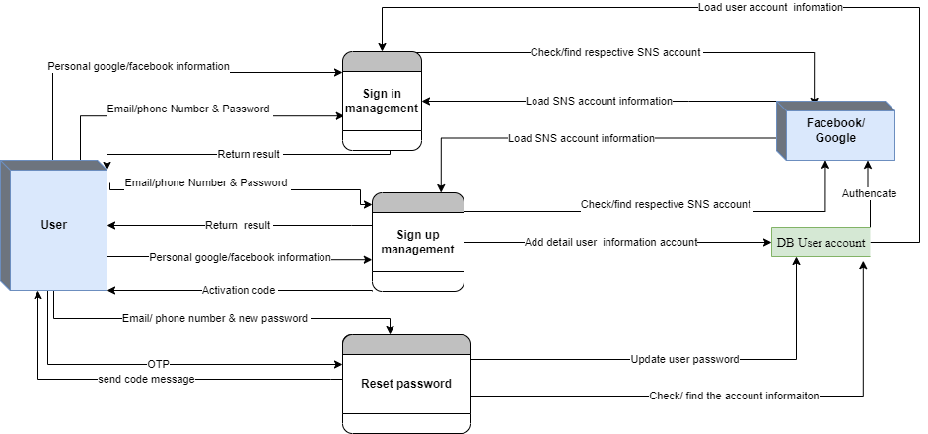

*Figure : Healthcare function Sequence Diagram*

In this DFD level 1 there are 2 entities, 3 processes and 1 data store. entities include User, Device Device . Processes are “Manage customer account”, “create customer location”, and “reset password”. Data store is “User account”.

* **Process “Manage customer sign in”** 
  + Input: Email/phone Number & Password.
  + Output: Return result (system checks “User account information” database and send back result to user)
  + Input: Personal google/Facebook information
  + Output: Load SNS account information (system connect to device to load user SNS and authenticate that account at database and return result to user)
* **Process “Create customer account”**
  + Input: Email/phone Number & Password.
  + Output: Return Activation code & Return result ( system authenticate & add detail user at database and send back result to customer)
  + Input: Personal google/Facebook information
  + Output: Return result (System connect to device to check/find respective SNS account, authenticate that account at database and load all the information)
* **Process “ Reset password ”**
  + Input: Email/ phone number & new password.
  + Output:
    - OTP code ( check authentication at database )
    - Return new password (if successfully authenticate, update user information to database)

### III.1.3. Sequence Diagram

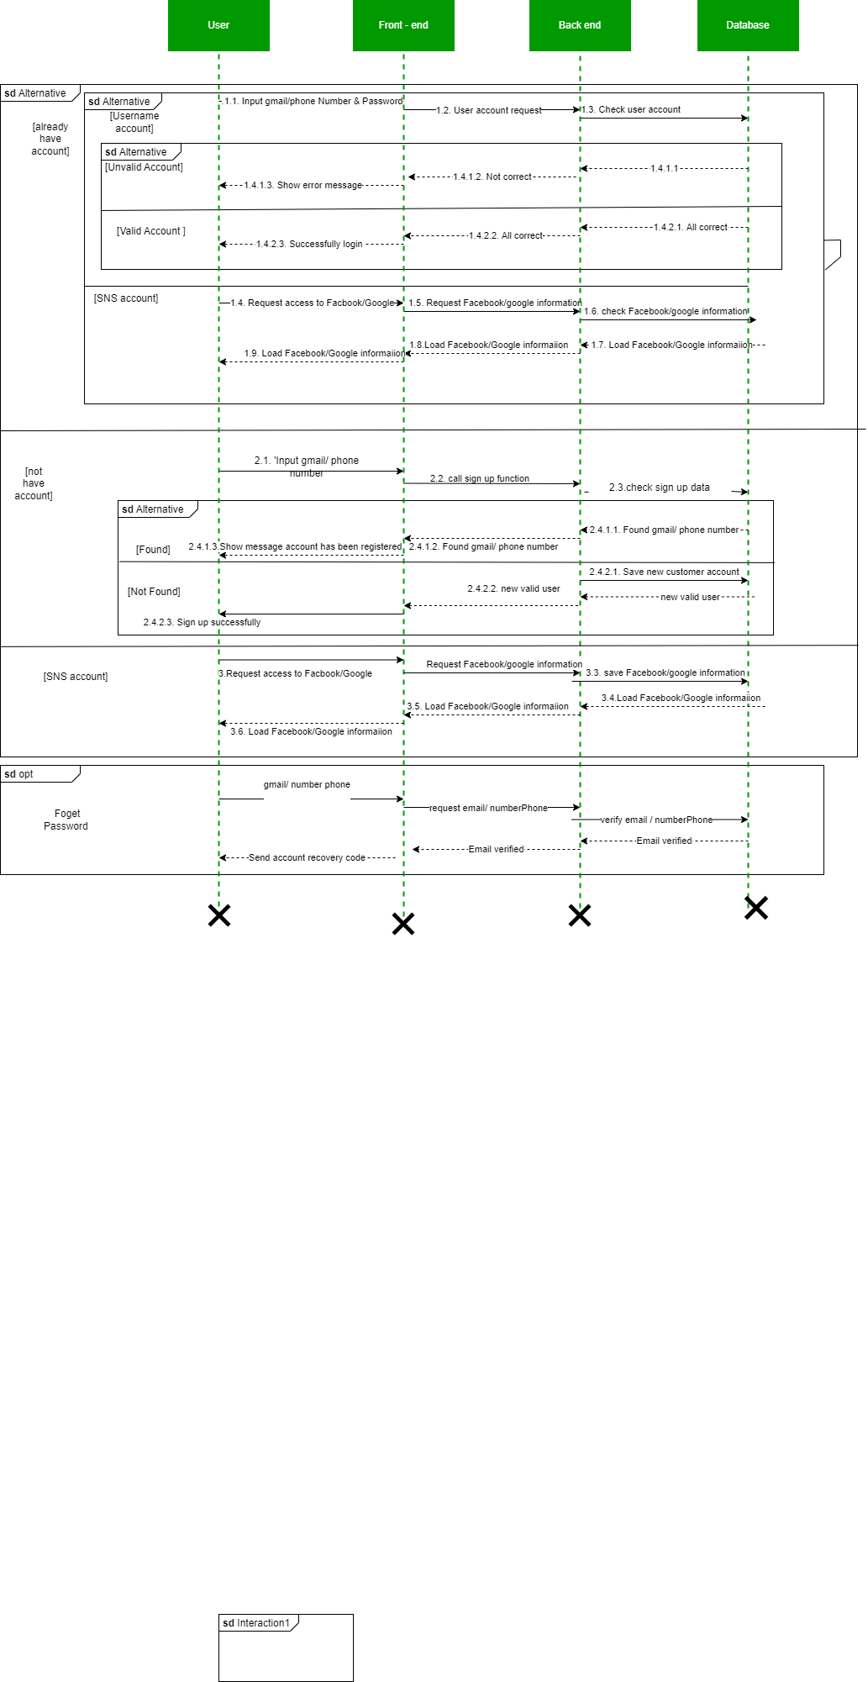

*Figure : Login Sequence Diagram*

### III.1.4. Mockup

The user must sign in in order to utilize functions like travel planning, health care, and emergency contact with family members. This is for information security reasons. The user selects "OK" to proceed to the sign-in or sign-up function.

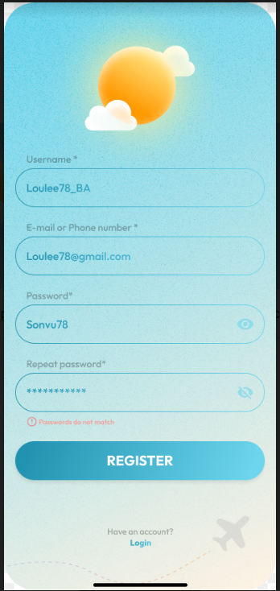

By selecting the buttons below, a user can easily join up using their Google or Facebook account if they prefer not to utilize a system account. Alternatively, the user can click "Sign up" at the bottom of the screen to proceed to the sign up page and establish a new account.

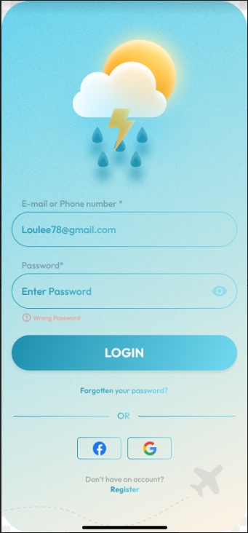

A forgot password? notifications appear and the user can reset his password using the "Forgot password?" tool. Users can input the email address or phone number connected to their account in a textbox on the program. The "Next" button aids the user in moving to the following screen. The user must enter the confirmation code on this screen.

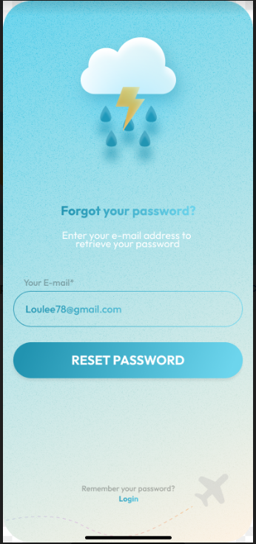

### III.1.5. Validation

**User account information with phone number**

| **Name** | **Data type** | **Key** | **Allow Null** | **Description** |
| --- | --- | --- | --- | --- |
| phone Number | varchar(10) | PK | No | Number phone of user |
| Password | varchar(20) |  | No | secret word or phrase that must be used to gain admission |

**User account information with Gmail**

| **Name** | **Data type** | **Key** | **Allow Null** | **Description** |
| --- | --- | --- | --- | --- |
| Gmail | varchar(10) | PK | No | Gmail account of user |
| Password | varchar(20) |  | No | secret word or phrase that must be used to gain admission |

**User account with Google**

| **Name** | **Data type** | **Key** | **Allow Null** | **Description** |
| --- | --- | --- | --- | --- |
| Gmail | varchar(10) | PK | No | Gmail account of user |
| Avatar | PNG |  |  | Picture of user email profile |
| User Name | Varchar(50) |  | No | Name of user email |

**User account with Facebook**

| **Name** | **Data type** | **Key** | **Allow Null** | **Description** |
| --- | --- | --- | --- | --- |
| Facebook Name | varchar(50) | PK | No | Facebook user name |
| Avatar | PNG |  |  | Picture profile of user facebook account |

## 

## **III.2. Function “Weather forecast”**

### III.2.1. Business process modeling notation (BPMN)

When users start the application, the application will check and send an Internet connection request to the user's phone (turn on Wifi/Cellular Data).

* Case 1: If users do not allow Internet access, the application will check the buffer memory. If the buffer memory has information, the application will display the weather information of the last location that users checked before.
* Case 2: Users allow the application to access the Internet:  
  The application will request to access the current location via GPS.
  + Case 2.1: Users allow the application to access GPS, get the user's current location via GPS.
  + Case 2.2: Users do not grant permission, the application will ask users to add a location.
    - Case 2.2.1: If users don't want, the application will automatically check the device settings to get the current Time Zone. Then define the location via Time Zone.
    - Case 2.2.2: On the contrary, if users want to add a location, the application will check the Location Database and display the locations that users have entered before. In case users want to select a new location that the Location Database does not have, the “Add a location” screen will display. Users continue to fill the location's name, the application will suggest the location's name based on Google Maps. After the location is selected. If data does not exist on FORECA, the application will show the message “Result not found” and let users re-enter the location's name. If the location exists, check whether the location has already existed in the Location Database or not. If not, update the new location to the Location Database.
* After getting the location, the application will connect to the FORECA data center, to get the weather forecast of the selected location and update it in the buffer memory.
* Display weather forecast information on the screen.

Figure: Weather forecast BPMN

### III.2.2. Data flow diagram (DFD)

In this DFD level 1 there are 4 entities, 4 processes and 3 data stores. entities include User, FORECA System, GPS, and Device Setting. Processes are “Login account”, “Identify location”, “Weather forecast” and “Show weather forecast & Warning Disaster”. Data store is “User account”, “Location database” and “Buffer memory”

* **Process “Login account”** 
  + Input: Account information of users (Users fill)
  + Output: Account status (system checks “User account” data store and send back status to users)
* **Process “Identify location”**
  + Input: Chosen location (by users enter from list of location has been saved in “Location database” or current location via “GPS” or Time Zone’s Location via Device setting)
  + Output: Location (save the new location in Location database)
* **Process “Connect to FORECA data center”**
  + Input: the location has been previously identified in “Identify location” process.
  + Output: Location and detailed weather forecast from FORECA (Update Details weather forecast into “Buffer memory” data store).
* **Process “Show weather forecast”**
  + Input: Latest details weather forecast from “Buffer memory” data store.
  + Output: Detailed weather forecast (present to “Users”)

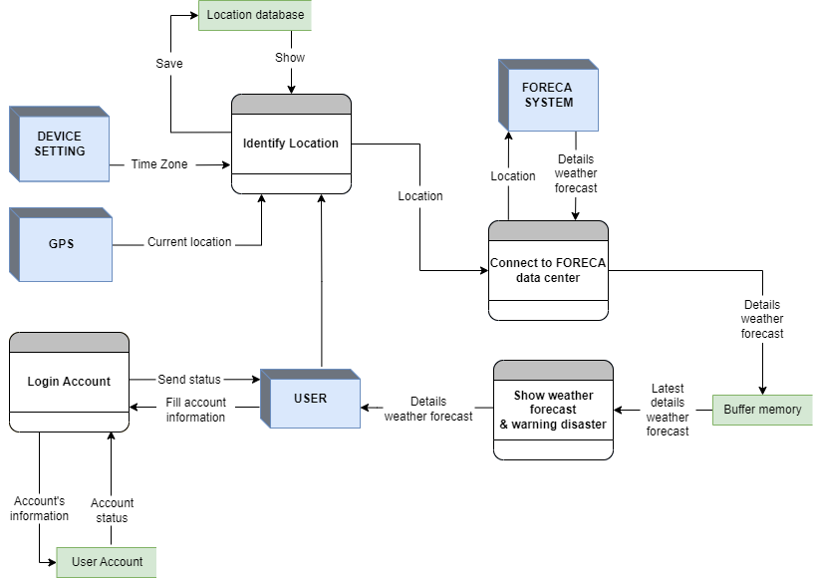

*Figure: Weather forecast DFD*

### III.2.3. Sequence Diagram

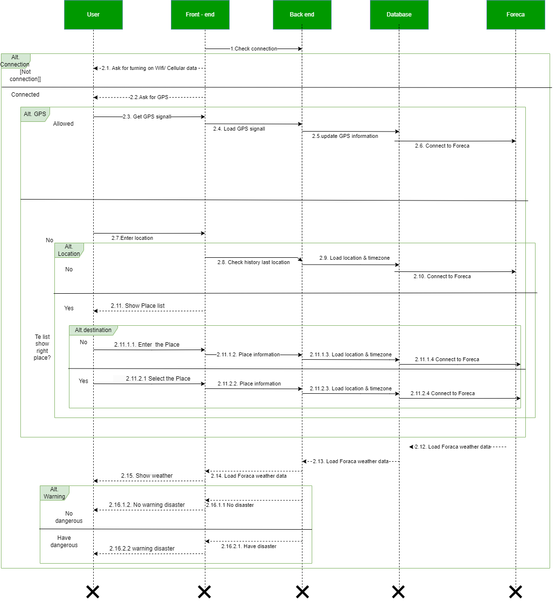

*Figure: Weather forecast_Sequence Diagram*

### 

### III.2.4. Mockup show detailed weather forecast

When using/opening the app, the system will initially prompt users to turn on Location Service Cellular data/Wifi if it is not already turned on.

|  | If the application doesn't have a city at first, a pop-up will prompt users to enable Location Services; if they decline, a search will be automatically displayed to add a city. |
| --- | --- |

* Show daily basic weather

### III.2.5. Validation

**III.2.5.2 Location Database**

This data store saves all locations which users chose.

| **Name** | **Data type** | **Key** | **Description** |
| --- | --- | --- | --- |
| Location_IP | Nvarchar(20) | PK | Store the IP address in that place |
| Location_Name | Nvarchar(50) |  | Address (street name and number) |
| Location_Details | Nvarchar(30) |  | County, city |

**III.2.5.2 Buffer Memory**

Buffer memory data store saves location and all weather details of this location at the last update.

| **Name** | **Data type** | **Key** | **Description** |
| --- | --- | --- | --- |
| Location_ID | Nvarchar | Yes | Location Identification |
| Location_Name | Nvarchar |  | Name of location |
| Weather_Details | Nvarchar |  | Information latest weather details of this location |

## **III.3. Function “Travel Planning”**

### III.3.1. Data flow diagram (DFD)

Generally, the DFD level 1 below includes 4 external entities, 7 data stores, and 8 processes.

In the beginning, logging in and ensuring the current location connection is completed. Here are some of our main processes.

* **Process: “Create travel plan”**
  + Input: Users send their traveling requirements
  + Output: List of appropriate itineraries and advisements for each suggestion.
* **Process: “Link to $3^{rd}$ parties booking”**: Users have to complete paid events to set an active mode for the confirmed schedule.
* **Process: “Review and modify travel plan”**
  + Input: Users choose valid schedules and modify selected events or entire schedules.
  + Output: Save to “Traveling Schedules”

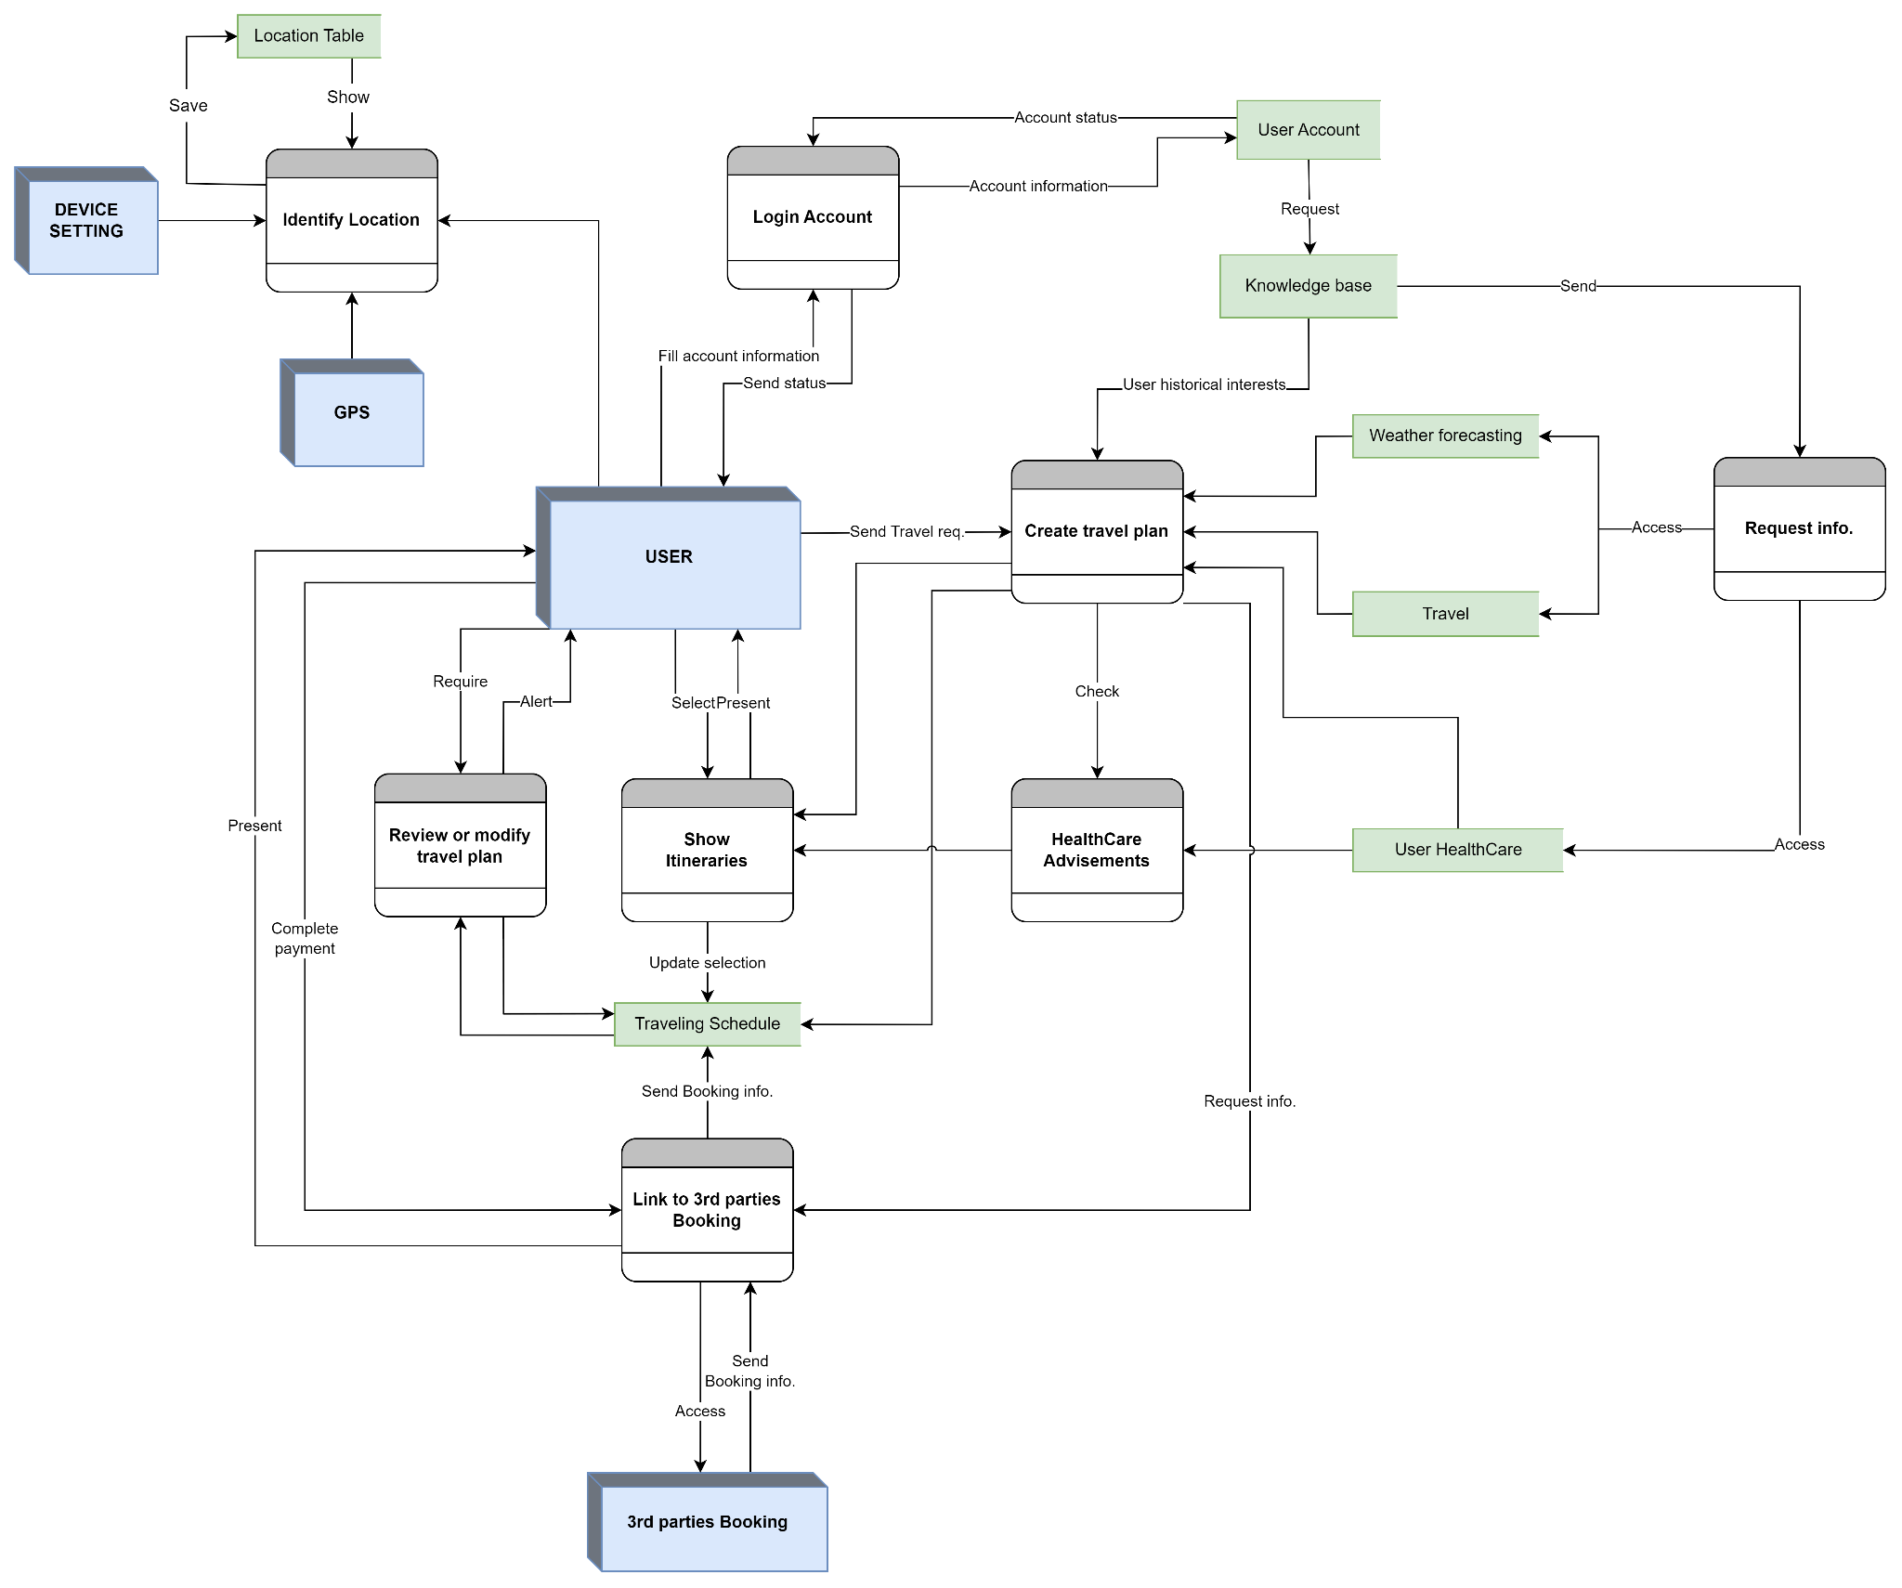

*Figure. DFD level 1 for Travel Planner function*

### III.3.3. Business process modeling notation (BPMN)

As mentioned, the Travel Planner feature allows for automatic travel planning based on user-defined criteria.

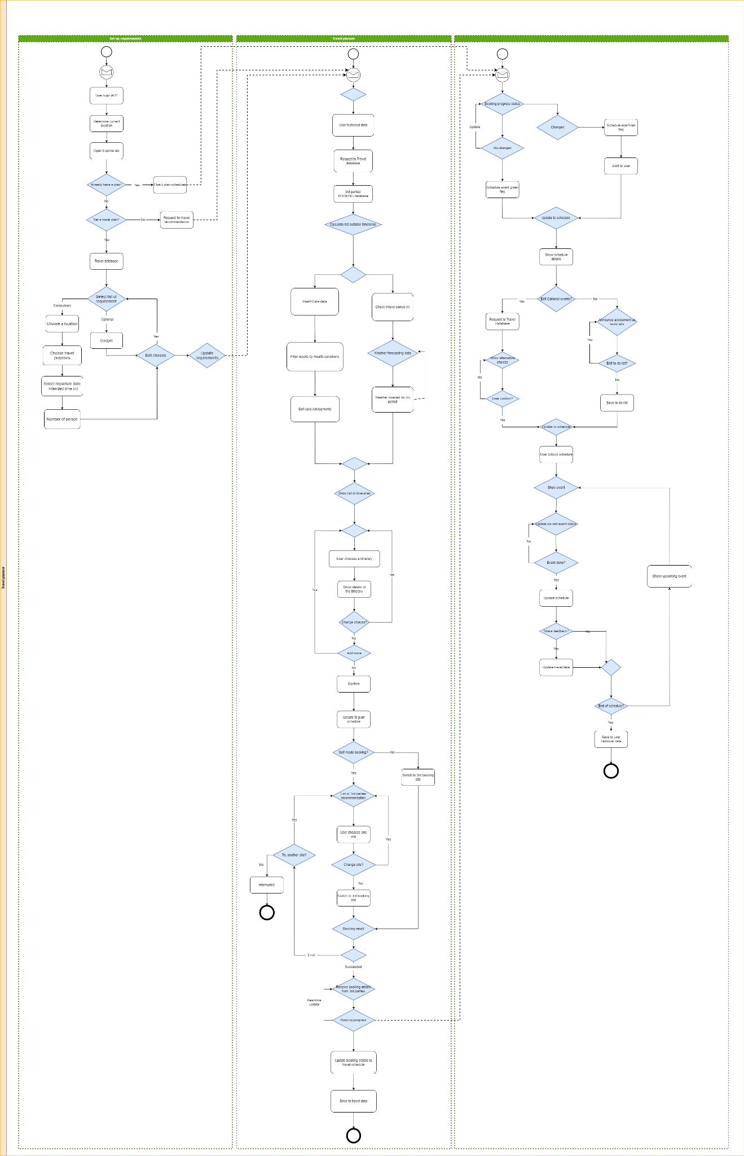

*Figure. BPMN for Travel planner function*

According to the BPMN diagram above, our function is separated into two circumstances:

* Case 1: Users have not created any traveling plans:
  + Explore traveling plans

For new users who don't have historical data yet, the system favors recommending travel packages with high user and rating without entering any trip attributes. Similarly, for those already making travel plans, the calculation of proposed results still impacts the knowledge base.

* + Create traveling plans

Firstly, users need to enter the trip information fields, which include required (Destination, trip purpose, departure date, intended time (n), number of people), and optional (Budget) information. Despite not knowing the appropriate budgets, this field allows it to be blank.

Afterward, based on the user's itineraries requirements and the catastrophic alerts from the weather forecasting process, it generates a list of results including health advice for each user's health status. In addition, the user’s health condition is going to determine the order of presented results, which means the safer selections come to the user’s health, the more prioritized position they appear.

Users have to select at least one result from the list of itineraries. Consequently, the selected result will be automatically added to traveling schedules as ongoing status.

Finally, to complete travel plans, users require to finalize payments for various bookings. Users can choose to pay for default recommendations in itineraries and make payments on third parties’ booking sites. If not, they are able to make bookings by themselves and the system will present a list of recommendations from third parties and link to sites to complete the payment. Subsequently, the third parties will send basic information about the trip (departure/return date, trip code, and other notes), which is saved and updated to traveling schedules.

* Case 2: Users have already created traveling plans:
  + View, edit, and delete traveling schedules or related events

Users are able to review their selected traveling schedules and can edit some optional events such as eating places, visiting destinations, and any free-of-charge events. While for paid events, we highly recommend not changing by sending alerts but still allow changing if necessary.

* + Receive announcements about events related to the itineraries

Thanks to GPS connections, our applications can follow their steps and send them alerts about the upcoming events of a specific schedule. In addition, if there were changes in reservation information and other unusual events, the travel schedule would be updated and alerted to users immediately.

### III.3.4. Sequence diagram

According to the BPMN description above, the Travel planner function is going to be presented as the “Travel” tab in our application. And the diagram below will explain the operation:

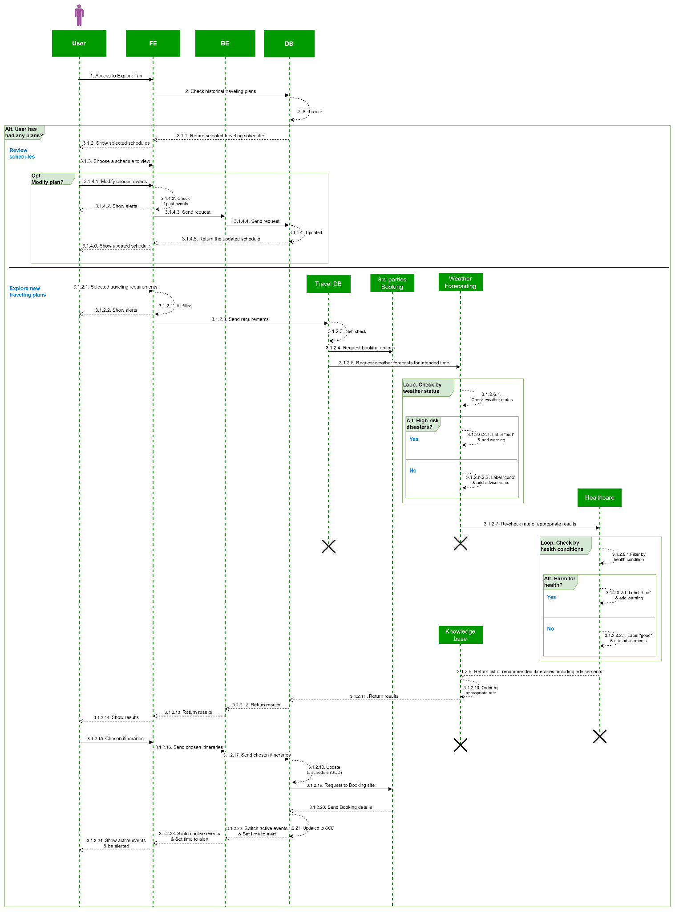

*Figure. Sequence Diagram for Travel planner function*

Due to the main description, we assumed that users succeeded in the login process and determining their location.

At first, users need to choose the “Travel” tab to review if they already have planned any traveling schedules or to create new itineraries by selecting some details about their travel. The booking process is not available in our application, though users can complete it on third parties’ sites and our system will update automatically booking details (supplied by booking parties) to alert them later and ensure schedules occur smoothly.

### III.3.5. Mockup

When chosen "Travel" tab, the main screen will show up your historical schedules. Users can expand a specific schedule to review more details. Moreover, they are able to edit and modify each schedule.

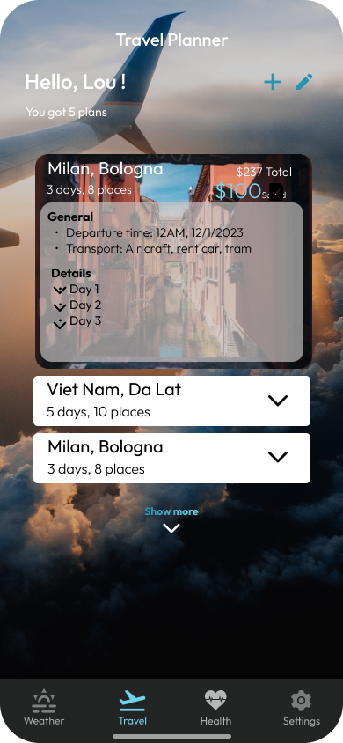

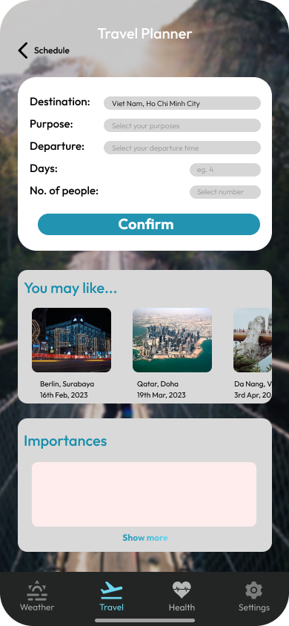

### III.3.6. Validation

* Traveling schedules

| **Name** | **Data type** | **Key** | **Allow Null** | **Validation** |
| --- | --- | --- | --- | --- |
| Schedule_ID | varchar(10) | PK | No |  |
| User_ID | varchar(10) | FK | No | Reference to User_Account |
| Itinerary_ID | varchar(10) | FK | No | Reference to Travel |
| Created_At | DateTime |  | No | When the schedule is created |
| Status | Bool |  | No | Schedule’s status:  0-Waiting  1-Active |
| Requirements | varchar(255) |  | No | User’s traveling requirements |
| SCD_Events | varchar(255) |  | No | Including original events from the itinerary and Booking details |

* Travel

| **Name** | **Data type** | **Key** | **Allow Null** | **Description** |
| --- | --- | --- | --- | --- |
| Itinerary_ID | varchar(10) | PK | No | Number of an itinerary |
| Region | varchar(10) |  | No | Itinerary happened in which regions. |
| TravelPurpose | varchar(10) |  | No | Travel’s purposes |
| Events | nvarchar(255) |  | No | List of events in the itinerary (places, booking) |
| Rated point | float |  | No | Average point was scored by experiencers [0-5] |
| Note | varchar(255) |  | Yes | Notions for itineraries |

## **III.4. Function “Healthcare”**

The Healthcare function is purpose-built to measure user health through current weather and medical metrics. From there, the system will make recommendations that are suitable for each level of danger from low to high to be able to best support users.

### III.4.1. Data flow diagram (DFD)

In DFD, there are 5 external entities, 8 data stores and 9 processes.

Five external entities are “User”, “Hospital”, “Smart watch”, “GPS” and “Weather forecast system”.

Eight data stores are "Smart Watch store", “Health dictionary”, "User's Health History Data", "Health status", "Hospital", "Suggestion Dictionary", "User's Phonebook", “Phone emergency”.

There are 9 processes as follows:

* **Process “Login”**
  + Input: User provides user name, password and data storage
  + Output: Login is successful or unsuccessful. If successful, open the right to connect to Smart Watch.
* **Process “Connect with Smart Watch”**
  + Input: The user provides information such as Smart Watch, Smart Watch ID and the result of successful login or not. Check the connection history, refuse to connect history before with the Smart Watch from the Database.
  + Output: Health indicators to check the user's health at the current time. Then save to Database
* **Process “Detect Insurance Number”**
  + Input: Users provide information including: phone number, health Insurance ID and hospital. Then will get the information sent to the hospital entered by the user to check.
  + Output:(1) The hospital returns the results after checking the information with the Medical Record information. (2) From there, return the result to the user whether the Health Insurance ID is successfully verified or not.
* **Process “Get Medical Record”**
  + Input: The system receives information about Medical Records from the hospital.
  + Output: Save to Database.
* **Process “Choose the diseases that (suffered) are suffering”**
  + Input: This process occurs when the user does not provide a Health Insurance ID. Get a list of diseases (based on WHO's international ICD code) that affect a lot when the weather changes and send it as a list for users to choose.
  + Output: Get a history list of diseases the user has. Save to the database.
* **Process “Take data from Weather Forecast Function (GPS and Weather)”**
  + Input: The app will get access to GPS to get user location and access to the weather forecast system to get current weather conditions.
  + Output: Send informations to process “Compare symptoms of diseases and health infor”
* **Process “Compare symptoms of diseases and health infor”**
  + Input: The user and the system will provide full information from the above processes including: Smart Watch, Medical Record, List of Diseases (through ICD code), Weather, GPS.
  + Output: Compare information from Smart Watch and symptoms from List of Diseases, then compare with Medical Record and with Weather. Finally, use GPS to locate support for the “Suggestions management” process.
* **Process “Get phonebook details”**
  + Input: User opens permission to access Phonebook in phone and provides 5 close contacts (choose from list of phone numbers in Phonebook or import externally)
  + Output: Send 5 contacts to the “Suggestions management” process and save to the database.
* **Process “Suggestions management”**
  + Input: The user provides information based on the results from the previous process.
  + Output: Send notifications to users and make recommendations tailored to the user's current status. If in an emergency, send a message to the 5 contacts provided and provide an additional emergency phone.

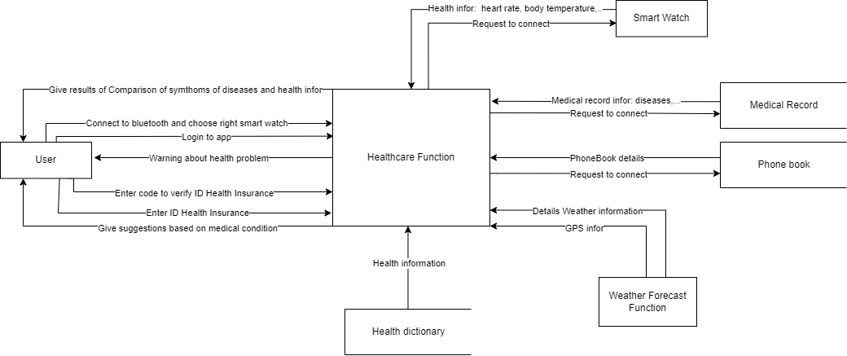

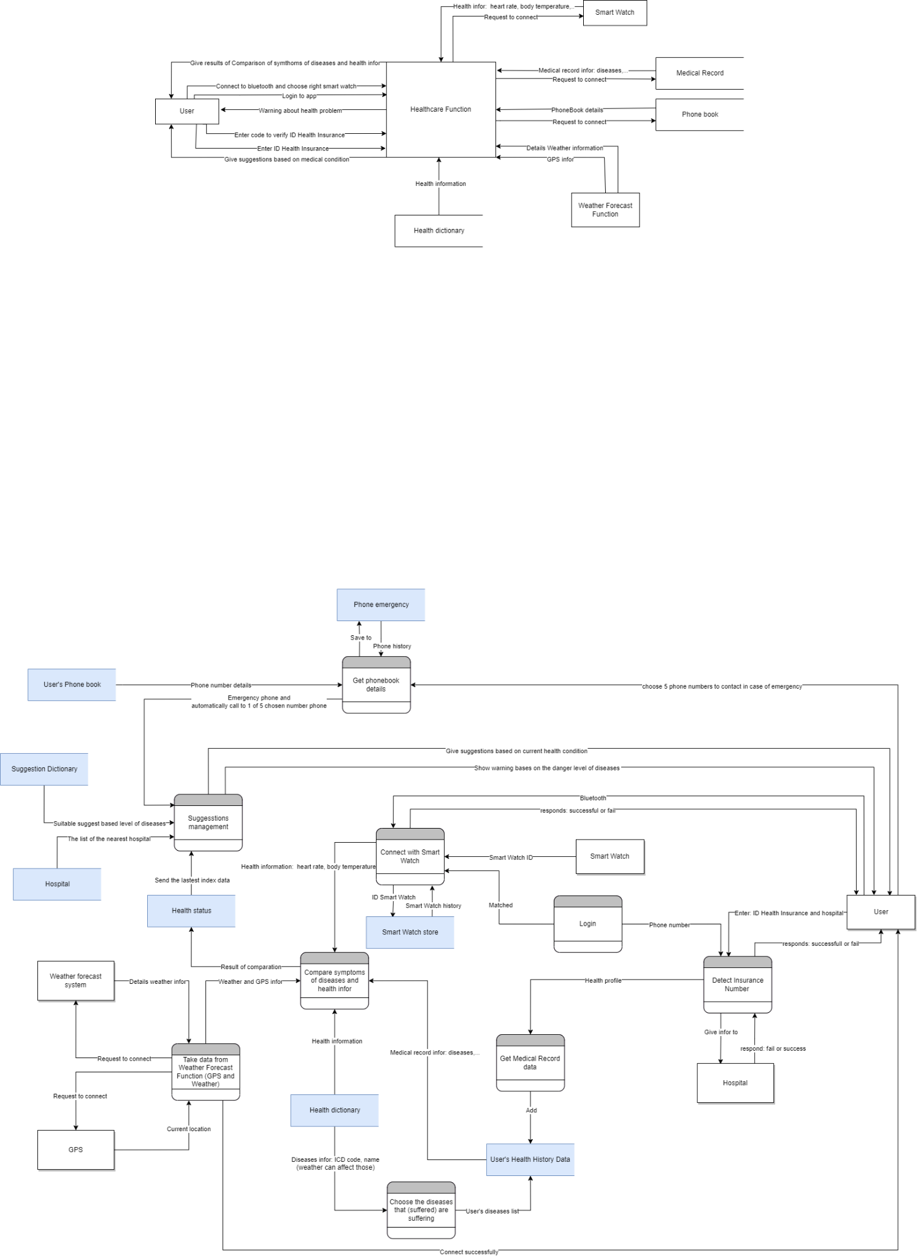

*Figure: Healthcare function DFD*

### III.4.2. Business process modeling notation (BPMN)

The user is required to successfully complete the “login process” in Login Function to start the steps in this function.

* **Check connection with Smart Watch:**

After completing the login to the application, the system will start to check the connection with the Smart Watch. There are 2 cases below:

* Case 1: Not connected to the Smart Watch
* Case 1.1: Users who have logged into the system before
  + Check connection history.
  + If the user used to connect, check the connection refused history.
  + If the user did not refuse the connection at the last time, then make a request to connect to the Smart Watch.
  + Choose the Smart Watch that you want to connect.
  + Application gets health information from Smart Watch and saves.
* Case 1.2: First time user logs into the system
  + Make a request to connect to the Smart Watch.
  + Choose the Smart Watch that you want to connect.
  + Application gets health information from Smart Watch and saves.

(*) If the user refuses at any step, then end the process there and continue to the connection process with Medical Record.

| **No.** | **Description** | **The first time login** | | **Not the first time login** | | | | |
| --- | --- | --- | --- | --- | --- | --- | --- | --- |
| 1 | Action |  | | Check connection history | | | | |
| 2 | Result | Used to connect | | | Never connected before | |
| 3 | Action | Check connection rejection history | | |  | |
| 4 | Result | Do not refuse at the last time | | Refuse at the last time |
| 5 | Action | Request to connect to the Smart Watch? | | | |  |
| 6 | Result | No | Yes | Yes | No |
| 7 | Action |  | Choose the Smart Watch want to connect | |  |
| 8 | Action | Get health information from Smart Watch | |

*Table: The steps in the SmartWatch connection procedure follow the table*

* Case 2: Connected to the Smart Watch

If the application is connected to the Smart Watch, the system will get the user's health information from the Smart Watch.

* **Connection with Medical Record**

After completing the connection process to the Smart Watch, the system will continue to check the connection to the Medical Record. There are 2 cases below:

* Case 1:Not yet connected to Medical Record

Requires connection to the user's Medical Record. The following cases occur:

* Case 1.1: User agrees to connect
  + User enters Health Insurance number and selects hospital
  + The system sends a confirmation OTP code
  + If the confirmation is successful, send the information the user has just entered to the hospital for checking.
  + When the test is complete, a successful message will be displayed on the screen.
  + The system takes the user's health history information and saves it.
* Case 1.2: User refused to connect
  + Displays diseases that are heavily influenced by the weather.
  + The user selects the diseases he has had in the list listed
  + Display "Success" screen
  + Save user health history.

| **No.** | **Description** | **User agrees to connect** | | | **User refused to connect** |
| --- | --- | --- | --- | --- | --- |
| 1 | Action | Show list of hospitals | | | Displays diseases that are heavily influenced by the weather. |
| 2 | Action | User enters Health Insurance code and selects hospital | | | The user chooses the diseases he has had |
| 3 | Action | The system sends a confirmation OTP code | | | Show "Success" screen |
| 4 | Result | Success | | Failure |  |
| 5 | Action | Health Insurance code information sent to the hospital | | Return to the connection request step. |
| 6 | Action | Hospital check | |  |
| 7 | Result | Success | Failure |
| 8 | Action | Show "Success" screen | Return to the connection request step. |
| 9 | Action | The system takes the user's health history information and saves it. |  | Save user health history. |

*Table:The steps in the Medical Record connection procedure follow the table*

* Case 2: The user connected to Medical Record or entered the required steps from the system

If the application has connected to the Medical Record, the system will get the information from the Medical Record to use.

* **Connection with Phonebook**

After completing the connection process to the Medical Record, you will continue the process of checking the connection to the Phonebook. There are two cases:

* Case 1: Not yet connected with Phonebook

The system will start with checking if the user has ever connected to a Phonebook before.

* Case 1.1: The first time login
  + The system sends a request to log in to Phonebook
  + If the user agrees, then navigate to the “Settings” page in the phone and the user selects “Allow” to unlock the application permission to access the Phonebook.
  + Continue, the system will navigate back to the main screen of the application and check the connection.
  + If the connection is successful, save the information.
  + The system asks the user if he wants to add the 5 close contacts to use during an emergency?
  + If the user agrees then the user has to select or enter those 5 contacts.
  + The application saves and updates user information.
* Case 1.2: Not the first time login
  + Continue with the next process.

(*) If the user declines at any step, then end the sub-process there and go to the next request in the process.

| **No.** | **Description** | **The first time login** | | | | | | **Not the first time login** |
| --- | --- | --- | --- | --- | --- | --- | --- | --- |
| 1 | Action | The system sends a request to log in to Phonebook | | | | | |  |
| 2 | Result | Yes | | | | No | |
| 3 | Action | Go to “Settings” page | | | |  | |
| 4 | Action | User choose “Allow” option | | | |
| 5 | Action | Back to the main screen | | | |
| 6 | Action | Check the connection | | | |
| 7 | Result | No | | Yes | |
| 8 | Action | Return to the connection request step. | | Lưu thông tin. | |
| 9 | Action |  | | Choose 5 close contacts? | | | |
| 10 | Result | No | Yes | Yes | No |
| 11 | Action |  | The system displays a list of phone numbers. | |  |
| 12 | Action | The user selects from the list or enters another number. | |
| 13 | Action | Update user information. | |

*Table: The steps in the Phonebook connection procedure follow the table*

* Case 2: Connected to the Phonebook

If already connected to the Phonebook, the system will continue to the next process.

* **Connection with Weather Forecast Function**

After completing the process of connecting to the Phonebook, it will continue to the process of automatically connecting to the Weather Forecast Function.

Purpose: Connect to the Weather Function to get the current weather and user location to support further processes.

* **Health tracking**

After getting the information from the Weather Forecast Function and going through the previous steps, the system will start to perform the real-time health tracking function of the user.

* First, the system will filter out diseases that can have a strong impact on health in the current weather.
* After having the above list of diseases, the system continues to filter out the diseases that the user is - has had based on the provided Medical Record information.
* The system will classify users into the following 2 cases:

| **No.** | **Description** | **Connected with Smart Watch** | | | | | | **Not connected with Smart Watch** | |
| --- | --- | --- | --- | --- | --- | --- | --- | --- | --- |
| 1 | Action | Retrieve current health information (including heart rate, body temperature, physical movement, breathing rate) | | | | | |  | |
| 2 | Action | Compare the symptoms of those diseases with the health information of the smart watch. | | | | | |
| 3 | Action | Classification (based on symptoms and current condition) | | | | | | Classification (based on the severity of the disease on an international scale) | |
| 4 | Result | Low risk | | | Moderate risk | | | | High risk |

*Table: Heath tracking table*

* **Suggestion management**

After completing the Health tracking process, the system will continue to make suggestions based on the evaluation levels obtained from Health tracking.

The level of danger is divided into 3 levels:

* Low risk
* Moderate risk
* High risk

With the different level, the system will offer different solutions and recommendations to users.

(*) The system will track health in real time and only notify the user when there is a special or unusual change based on information from the user's smart watch.

**1. Low risk**

Description: This is the lowest risk of the three levels. Users at this level are in very good to normal health and have no dangerous symptoms.

* Show on the screen "The current weather doesn't affect you"

**2. Moderate risk**

Description: This is the average risk level of the three levels. Users at this level have a slightly unhealthy condition. Signs may be: slight dizziness, slight abdominal pain, slightly increased heart rate, breathing rate a little higher or lower than standard, . . . Symptoms appear but are not too life-threatening.

* Show "The current weather is bad for you"
* Make suggestions to users who need a supervisor by their side.
* The system starts searching for the nearest hospitals (preferably hospitals in Health Insurance)
* Send information about the nearest hospitals to users.

**3. High risk**

Description: This is the highest risk of the three levels. Users of this level have very bad health. Dangerous and unusual symptoms, with signs of danger to life.

* Show "The current weather is very bad for you"
* Make suggestions to the user that they need a supervisor.
* The system starts searching for the nearest hospitals (preferably hospitals in Health Insurance)
* Send information about the nearest hospitals to users.
* Based on the level of information provided by users, divided into two cases as follows:

| **No.** | **Description** | **Connected with Phonebook** | | **Not connected with Phonebook** | |
| --- | --- | --- | --- | --- | --- |
| 1 | Action | Check the user has entered the 5 close contacts. | | Check where the user is now | |
| 2 | Result | Entered | Not entered | Việt Nam | Nước ngoài |
| 3 | Action | Automatically send messages to those 5 people | Give a list of the 5 most contacted people |  | Give embassy information. |
| 4 | Action | Show emergency phone number | | | |

*Table: Find support on Suggestion management*

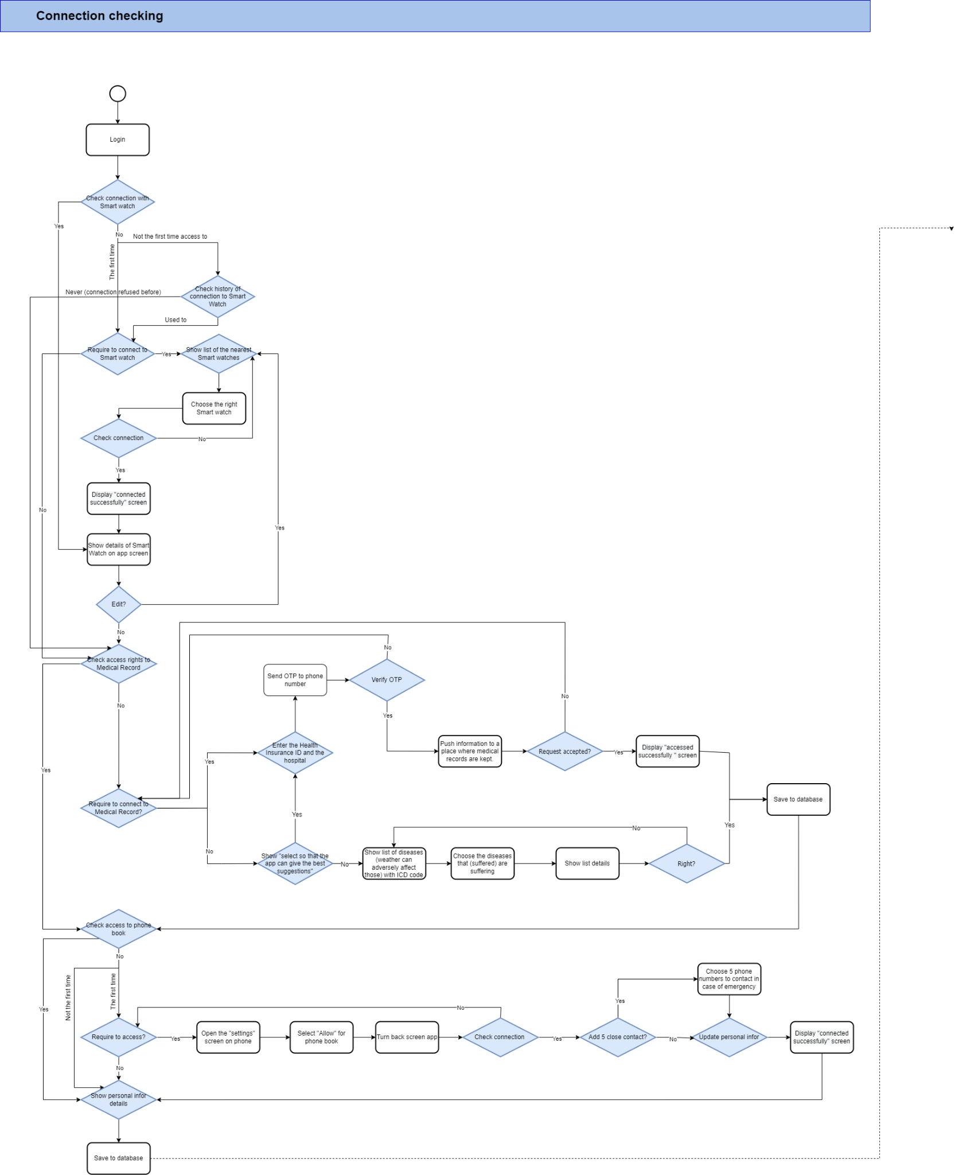

*Figure: Healthcare function BPMN_1*

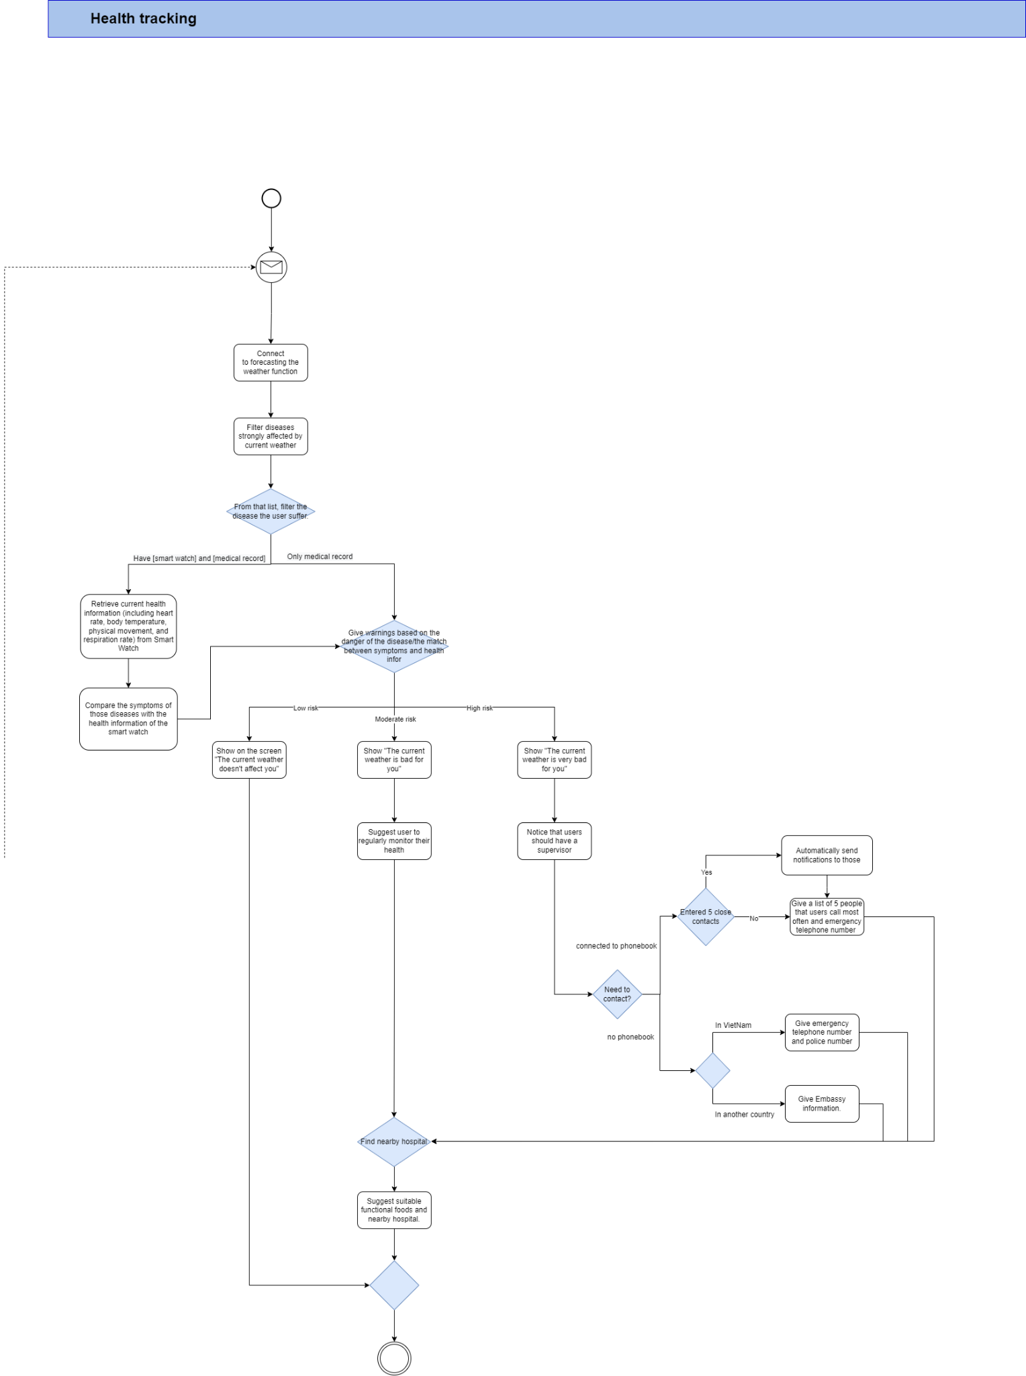

*Figure: Healthcare function BPMN_2*

### III.4.3. Sequence Diagram

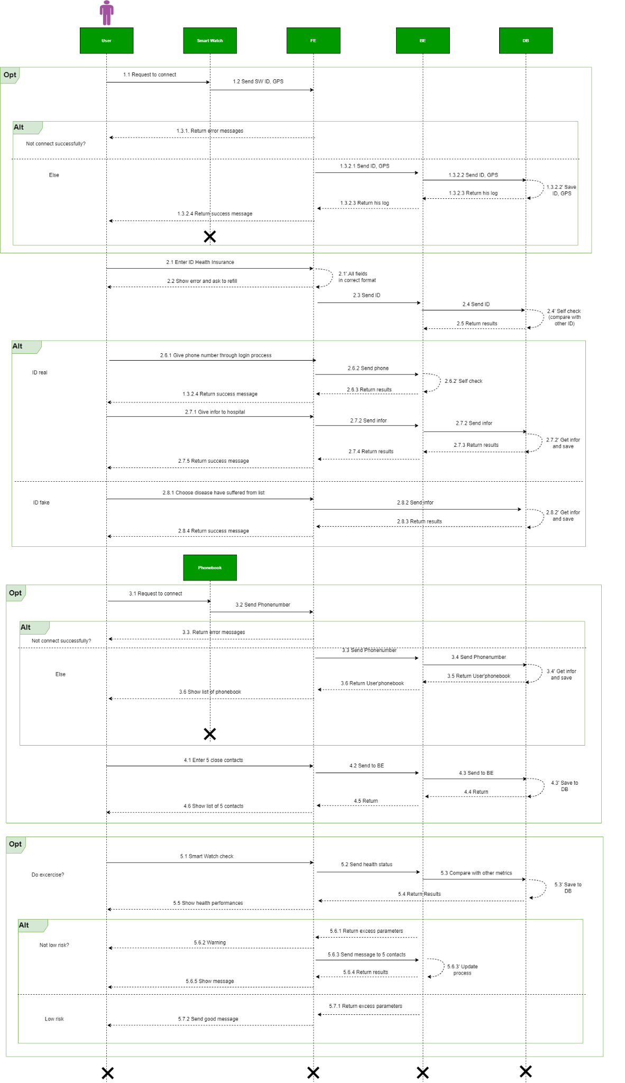

*Figure : Healthcare function Sequence Diagram*

### III.4.4. Mockup

If the user has not enabled Bluetooth mode, a little window titled "Request to connect to input health information" will appear when they choose the healthcare feature. Users only need to choose "Setting" from that point on to proceed.

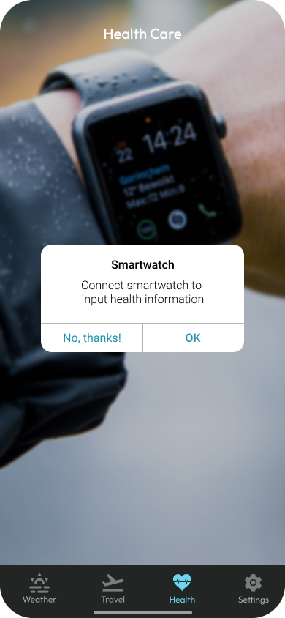

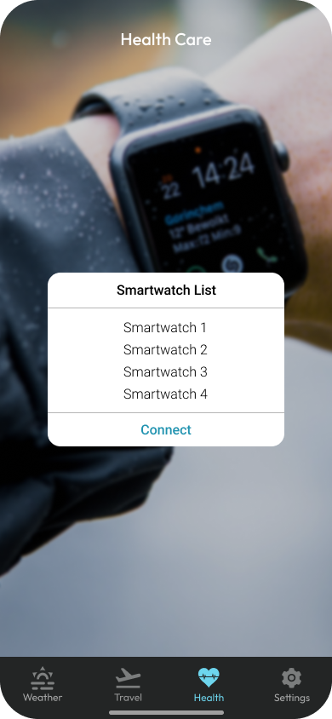

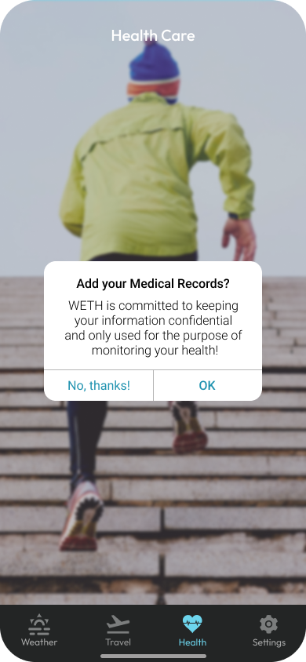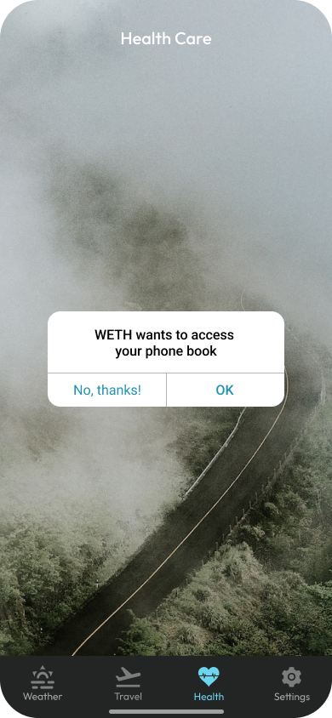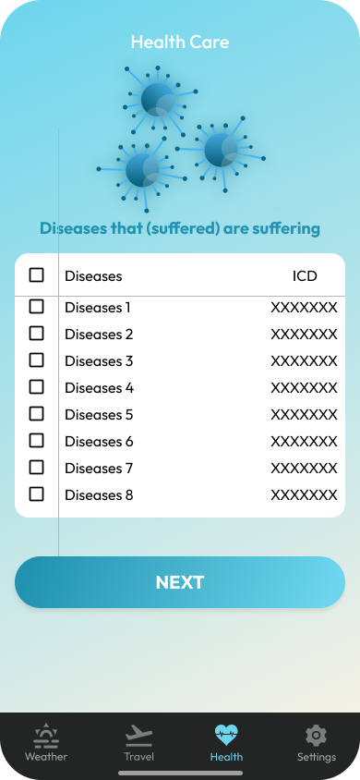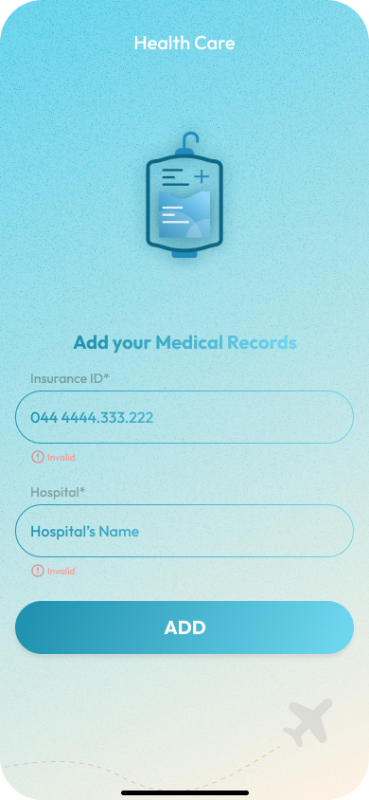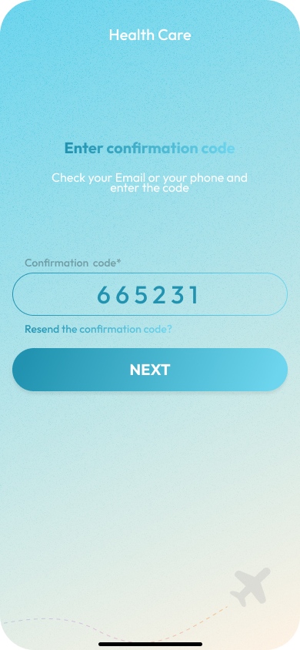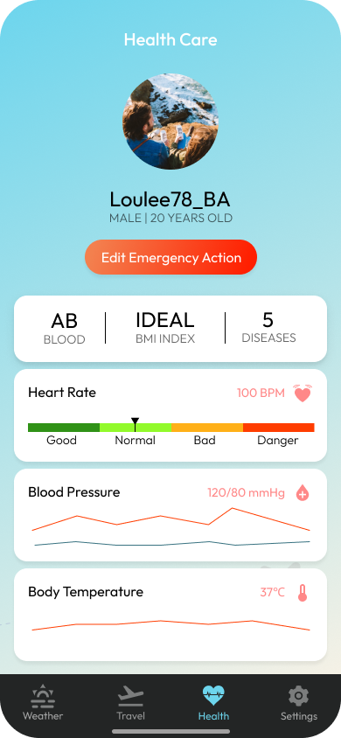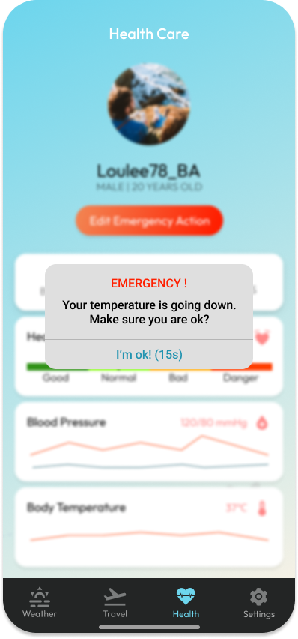

### III.4.5. Validation

**Smart Watch store**

When the user connects to the Smart Watch, the information will be saved to the Smart Watch store

| **Attribute** | **Data type** | **Primary Key** | **Description** |
| --- | --- | --- | --- |
| ID_Smartwatch | Int | x | Identification Smart Watch |
| Details | Nvarchar |  | Details of SW |
| Connect_date | Datetime |  | Day of connection |

**Health dictionary**

The data is taken from the official WHO site including the ICD codes of the diseases (the diseases are mostly related to the weather).

| **Attribute** | **Data type** | **Primary Key** | **Description** |
| --- | --- | --- | --- |
| ICD_code | Nvarchar | x | code of disease |
| Details_disease | Nvarchar |  |  |
| Level_of_disease | Int |  | The danger level of disease |

**User's Health History Data**

Historical data of diseases the user has had.

| **Attribute** | **Data type** | **Primary Key** | **Description** |
| --- | --- | --- | --- |
| Name_of_disease | Nvarchar | x | Name of disease |
| ICD_code | Nvarchar | FK |  |
| ID_user | Int |  | Identification of the user |
| ID_Insurance | Nvarchar |  | Identification of the user’s medical record |
| Details_disease | Nvarchar |  |  |
| Symptoms | Nvarchar |  | symptoms of the disease |

**Health status**

After comparing the weather data, Smart Watch with Medical Record, the user's current status data will be saved.

| **Attribute** | **Data type** | **Primary Key** | **Description** |
| --- | --- | --- | --- |
| Name_of disease | Nvarchar |  |  |
| ICD_code | Nvarchar |  |  |
| ID_user | Int |  |  |
| Details | Nvarchar |  |  |
| Health_status | Nvarchar |  | Measure into 3 levels (low - moderate - high) |

**Hospital**

List of hospitals

| **Attribute** | **Data type** | **Primary Key** | **Description** |
| --- | --- | --- | --- |
| ID_hospital | Nvarchar | x |  |
| Hospital_location | Nvarchar |  | Hospital address |
| Hospital_money | Float |  | Payment price |
| Hospital_details | Nvarchar |  |  |

**Suggestion Dictionary**

Lists of advice, warnings and recommendations tailored to each audience. Activate separate actions for each different level.

| **Attribute** | **Data type** | **Primary Key** | **Description** |
| --- | --- | --- | --- |
| ID_suggestion | Int | x |  |
| ICD_code | Nvarchar | FK |  |
| Suggestions | Nvarchar |  | Give suggestions to users |
| Action | Nvarchar |  | Provide appropriate recommendations for each different hazard level. |

**User's Phonebook**

List of phone numbers in user contacts

| **Attribute** | **Data type** | **Primary Key** | **Description** |
| --- | --- | --- | --- |
| Phone_number | Int | x |  |
| Phone_name | Nvarchar |  | The person using that phone number |
| Phone_details | Nvarchar |  |  |

**Phone emergency**

List of 5 emergency phone numbers

| **Attribute** | **Data type** | **Primary Key** | **Description** |
| --- | --- | --- | --- |
| ePhone_number | Int | x |  |
| ePhone_name | Nvarchar |  | The person using that phone number |

## III.5. Function “Personal Settings”

### III.5.1. Business process modeling notation (BPMN)

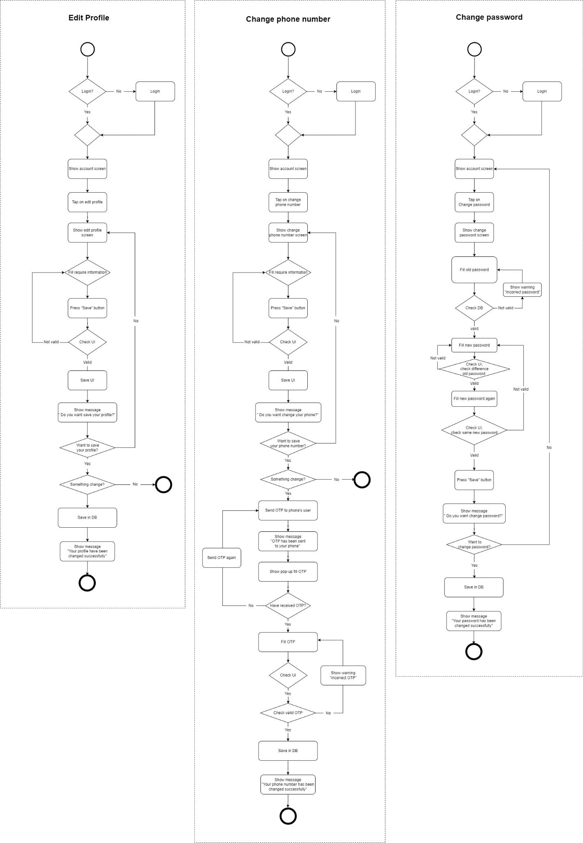

### III.5.4. Mockup

| Pic1: Setting_1 | Pic3: Edit account |
| --- | --- |
|  |  |
| Pic2: Setting_2 | Pic4: Confirm to Edit account |
|  |  |